**بسم الله الرحمن الرحیم**

سید مهدی حسن پور:smahdi1991@gmail.com

تمرین اول_python_142:

سوال1:

آیا زبان­هایی که از نوع static type هستند، هم انواع strong , weak دارند؟

پاسخ :

خیر، زیرا نوع ها در زبان های static در زمان کامپایل ثبت شده و نمیتوان مثلا یک عدد را با یک رشته جمع کرد ، پس قوی ضعیف در زبان استاتیک نداریم چون طبق طبیعت زبان باید هرچیزی نوعش مشخص باشه.

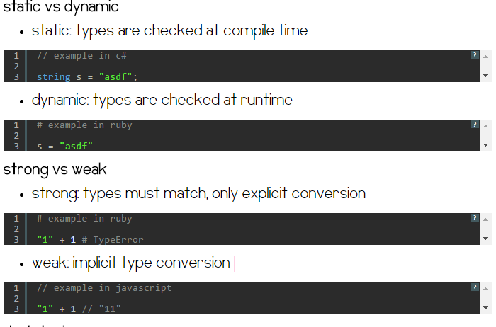

* دو مفهوم dynamic ,static در زیر آورده شده اند:

**Abstract**: Static typing is when your type checking occurs at compile time.

**Dynamically typed**

means that types are attached to values at run time, or Dynamic typed programming languages are those languages in which variables must necessarily be defined before they are used. This implies that dynamic typed languages do not require the explicit declaration of the variables before they’re used. Python is an example of a dynamic typed programming language, and so is PHP. Consider the following example:

/* Python code */

num = 10 #directly using the variable, num is defined and we didnt declare it previously, then num has a value that is equal to 10, and so on nums type will be integer

#it means num get its type at runtime

Num = ‘SeyyedMahdi’ #now num has a type of string value, so in dynamic typed language, nums type can be change easily at runtime

**Statically typed**

 means that types are checked at compile time, and a program that does not have a static type is rejected by the compiler. Or Static typed programming languages are those in which variables need not be defined before they’re used. This implies that static typing has to do with the explicit declaration (or initialization) of variables before they’re employed. Java is an example of a static typed language; C and C++ are also static typed languages. Note that in C (and C++ also), variables can be cast into other types, but they don’t get converted; you just read them assuming they are another type.

/* C code */

int num, sum; // explicit declaration

num = 5; // now use the variables

sum = 10;

sum = sum + num;

#num get its type at the compile time , and it types cant be change

* دو مفهوم strong and weak typeدر زیر توضیح داده شده اند:

**Abstract**: When you have strong typing, you will only be allowed operations on the data by direct manipulation of the objects of that data type.

**Strong Typing**

Programming languages in which variables have specific data types are strong typed. This implies that in strong typed languages, variables are necessarily bound to a particular data type. Python is strong typed, and so is Java. Or an attempt to mix values of different types may cause a "run-time type error".

/* Python code */

>>> foo = "x"

>>> foo = foo + 2

Traceback (most recent call last):

 File "<pyshell#3>", line 1, in ?

   foo = foo + 2

TypeError: cannot concatenate 'str' and 'int' objects

**Weak Typing**

As opposed to strong typed languages, weak typed languages are those in which variables are not of a specific data type. It should be noted that this does not imply that variables do not have types; it does mean that variables are not "bound" to a specific data type. PHP and C are examples of weak typed languages. Consider the following:

/* PHP code */

<?php

$foo = "x";

$foo = $foo + 2; // not an error

echo $foo;

?>

البته درباره زبان C:

C is considered statically typed (you can't have a variable change from int to float). Once a variable is declared it is stuck that way.

But it is considered weakly typed because the types can be flip flopped.

What is 0? '\0', FALSE, 0.0, etc..

in many languages you can't say IF (variable) because conditions will only take boolean values from boolean expressions. These are more strongly typed. The same applies to going between characters and integers.

basically c has two main simple data types, integers and floating point numbers (though various precisions). Everything else booleans, enums (not simple but it fits), etc. are implemented as one of those. Even characters are basically integers.

Compare to other languages where there are string types, enum types that can only be assigned to the defined values, boolean types where only expressions that generate booleans or true/false can be used.

But you can argue that compared to Perl C is strongly typed. So it is one of those famous arguments (vi vs emacs, linux vs windows, etc.). C# is stronger typed than C. Basically you can argue either way. And your answers will probably go both ways :) Also some textbooks/web pages will say C is weakly typed, and some will say C is strongly typed. If you go to wikipedia the C entry says "partially weak typing". I would say compared to Python C is weakly typed. So Python/C#, C, Perl on the continuum.

منابع :

* <https://www.sitepoint.com/typing-versus-dynamic-typing/>
* <http://stackoverflow.com/questions/430182/is-c-strongly-typed>
* <http://stackoverflow.com/questions/11889602/difference-between-strong-vs-static-typing-and-weak-vs-dynamic-typing>
* <http://www.koffeinfrei.org/2012/03/19/static-vs-dynamic-vs-strong-vs-weak-vs-duck-typing>